**10.1 Acetyl-CoA**

* Contains a high-energy thioester bond that can be used to drive other reactions when hydrolysis occurs
* Used by Krebs cycle → oxidation of acetyl-CoA to CO2 and H2O + production of high-energy electron carrying molecules NADH and FADH2

Methods of Forming Acetyl-CoA

|  |  |
| --- | --- |
| **Molecule** | **Mechanism of Conversion to Acetyl-CoA** |
| **Pyruvate dehydrogenase complex** | Pyruvate + CoA-SH + NAD+ → acetyl-CoA + CO2 + NADH + H+ |
| **Fatty acids** | Shuttle acyl group from cytosolic CoA-SH to mitochondrial CoA-SH via carnitine; then undergo β-oxidation |
| **Ketogenic amino acids** | Transaminate to lose nitrogen; convert carbon skeleton into ketone body, which can be converted into acetyl-CoA |
| **Ketones** | Reverse of ketone body formation |
| **Alcohol** | Alcohol dehydrogenase and acetaldehyde dehydrogenase convert alcohol into acetyl-CoA |

**10.2 Reactions of the Citric Acid Cycle**

Key Reactions

* Takes place in the mitochondrial matrix
* Main purpose is to oxidize carbons in the intermediates to CO2 and generate high-energy electron carriers (NADH and FADH2) and GTP

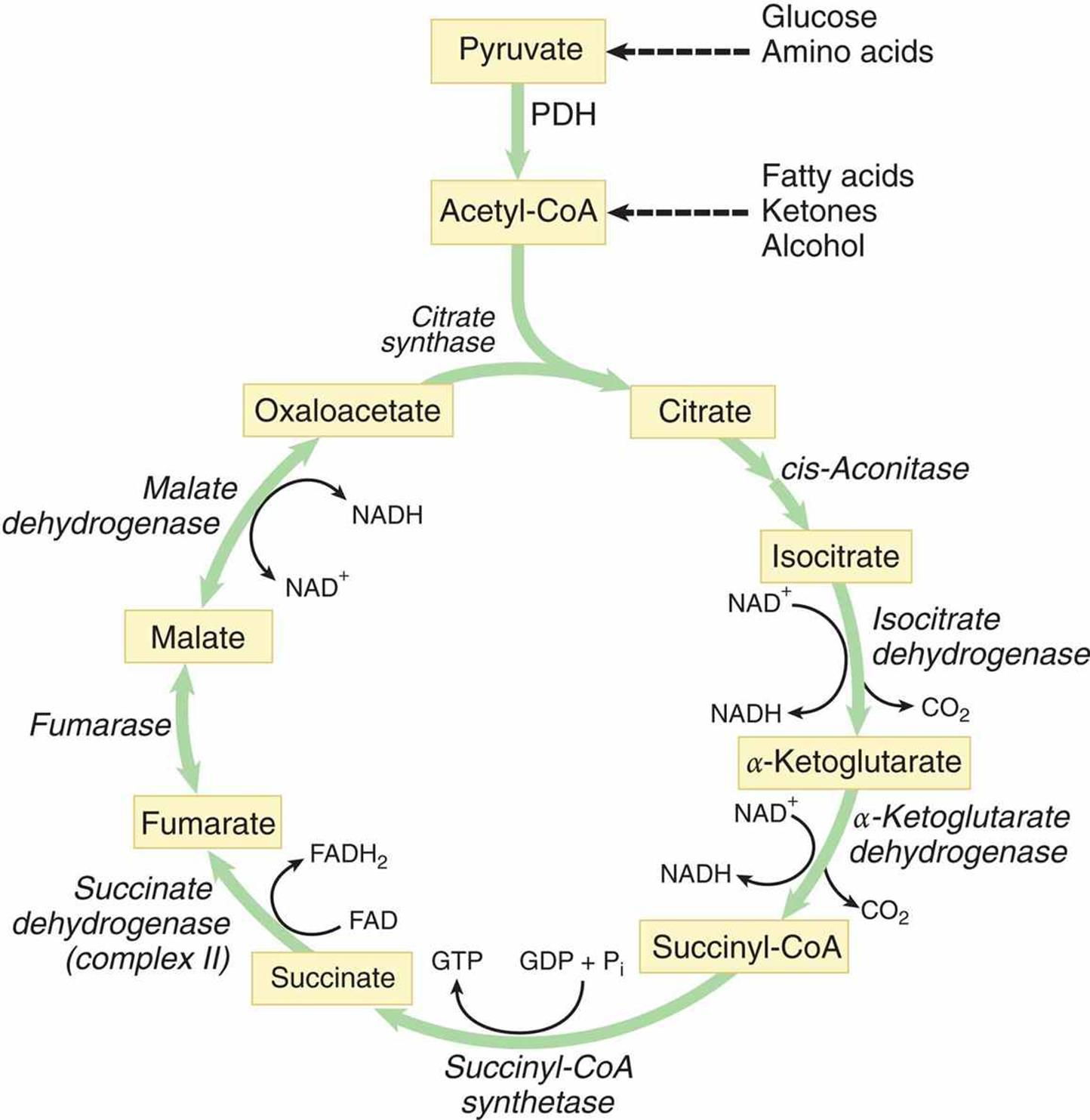

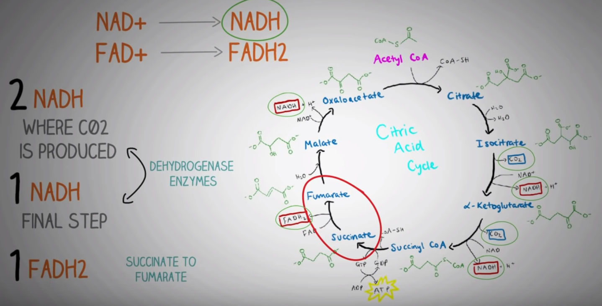

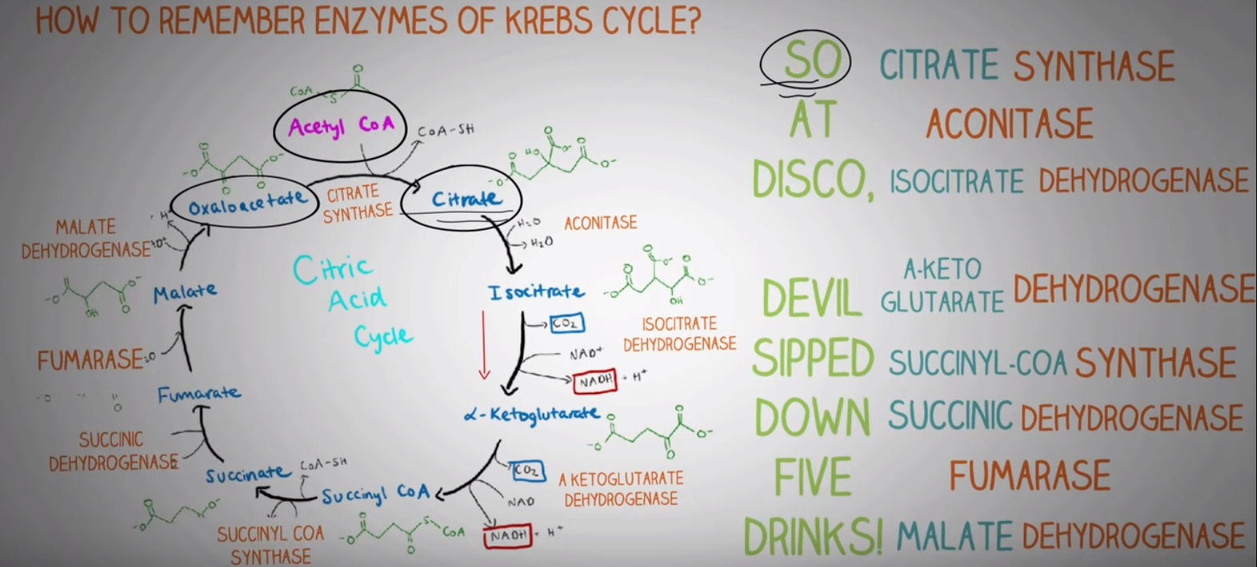

(Take note of the key enzyme in each step)

Net Results and ATP Yield

1. Glycolysis
   1. 4 (produced) - 2 (consumed) = **2 net ATP**
   2. **2 NADH**
2. Pyruvate Dehydrogenase Complex (x2)
   1. Pyruvate + CoA-SH + NAD+ → acetyl-CoA + **NADH** + CO2 + H+ (x2)
3. Citric acid cycle (x2)
   1. Acetyl-CoA + 3 NAD+ + FAD + GDP + Pi + 2 H2O → 2 CO2 + CoA-SH + **3** **NADH** + 3H+ + **FADH2** + **GTP** (x2)

Hence, total ATP production = **32 ATP**

* 2 net ATP
* 10 NADH → 25 ATP (2.5 ATP per NADH)
* 2 FADH2 → 3 ATP (1.5 ATP per FADH2)
* 2 GTP → 2 ATP

Regulation

* High levels of ATP and NADH inhibit the citric acid cycle while high levels of ADP and NAD+ promote it
* Isocitrate dehydrogenase is the rate-limiting step in Krebs cycle

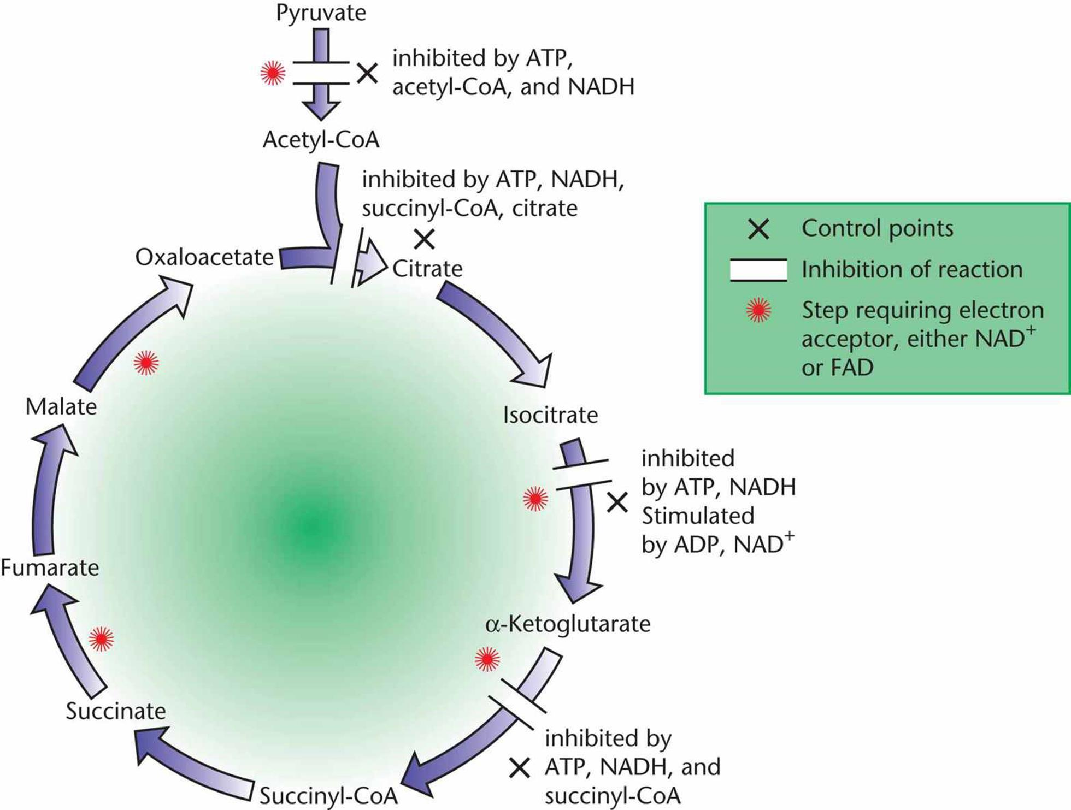

**10.3 The Electron Transport Chain**

Electron Flow and Complexes

* Pumping a proton into the intermembrane space: I, III, and IV
* Acquiring electrons from NADH: I
* Acquiring electrons from FADH2: II
* Having the highest reduction potential: IV (reduction potentials increase along the ETC)

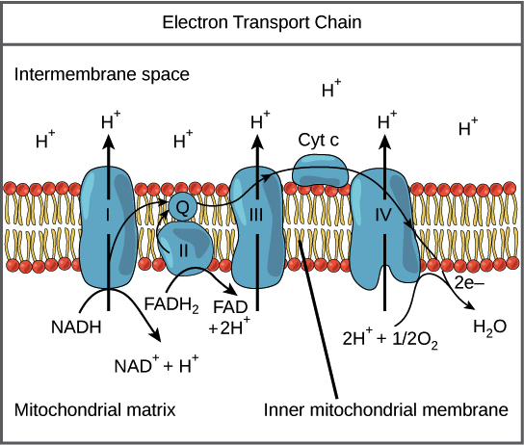

The Proton-Motive Force

* Electro-chemical gradient
  + [H+] increases in the intermembrane space → pH decreases
  + Voltage difference between the intermembrane space and matrix increases due to proton pumping

NADH Shuttles

* Cytosolic NADH formed through glycolysis cannot directly cross into the mitochondrial matrix → requires one of the 2 shuttle mechanisms (each generating 1.5 or 2 ATP → that’s why total net ATP yield exists between 30-32)

1. Glycerol 3-phosphate shuttle
   1. Electrons are transferred from NADH to DHAP, forming G3P
   2. These electrons can then be transferred to mitochondrial FAD, forming FADH2 (1.5 ATP)

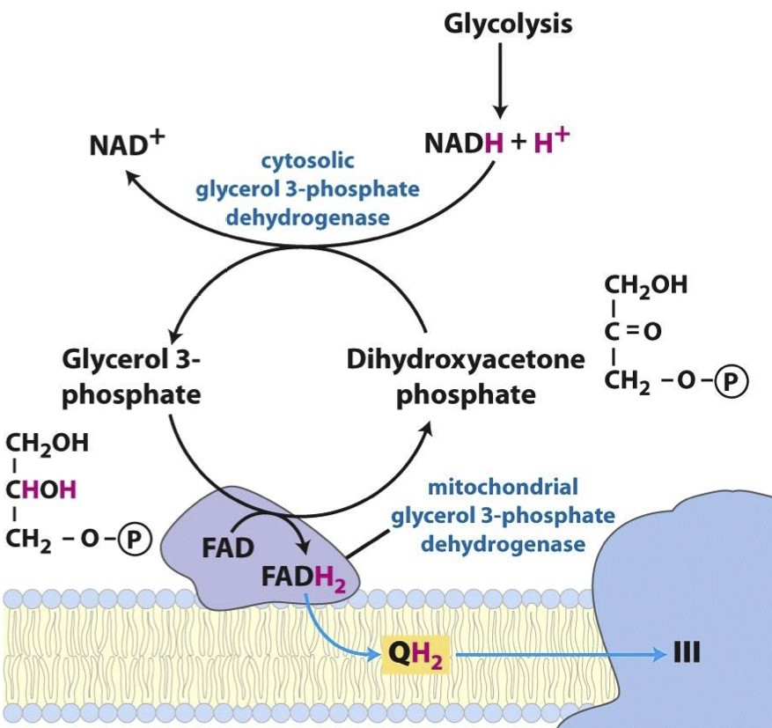

1. Malate-aspartate shuttle
   1. Electrons are transferred from NADH to oxaloacetate, forming malate
   2. Malate can then cross the inner mitochondrial membrane and transfer the electrons to mitochondrial NAD+, forming NADH

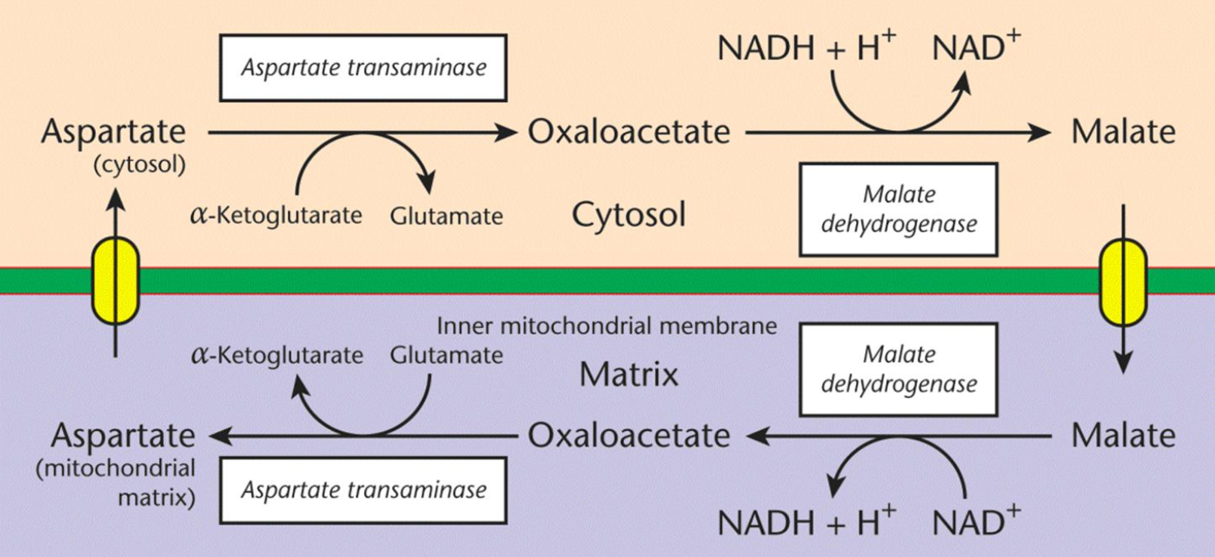

**10.4 Oxidative Phosphorylation**

Chemiosmotic Coupling

* The proton-motive force = electrochemical gradient generated by the ETC across the inner mitochondrial membrane
* The intermembrane space has a higher concentration of protons than the matrix → the gradient stores energy → can be used to form ATP via the chemiosmotic coupling
* ATP synthase is the enzyme responsible for generating ATP from ADP and Pi
  + F0 portion: ion channel allowing protons to flow down the gradient from the intermembrane space to the matrix
  + F1 portion: uses the energy released by the gradient to phosphorylate ADP into ATP

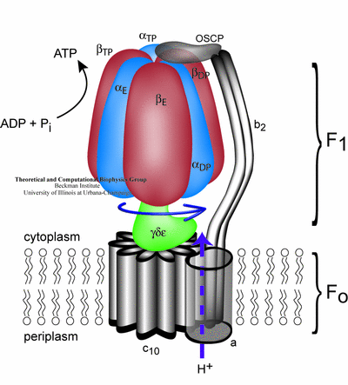

Regulation

* The rates of oxidative phosphorylation and the citric acid cycle are closely related (respiratory control)

1. Limited O2 → rate of oxidative phosphorylation decreases → concentration of NADH and FADH2 increase → accumulation of NADH inhibit citric acid cycle
2. Presence of O2 → **the rate of oxidative phosphorylation is then dependent on the availability of ADP** → ADP accumulation signals the need for ATP synthesis (since they are reciprocally related) → ADP allosterically activates isocitrate dehydrogenase → increases the rate of the citric acid cycle and the production of NADH and FADH2 → increase the rate of electron transport and ATP synthesis